AIM: Implementation of at least five different SQL nested sub queries in select clause on each Banking-University and DB Project assigned.
Procedure
Nested subqueries allow us to perform a query within another query, making them particularly useful for extracting specific, conditional, or aggregated information from related datasets. Here are the steps performed :
- Search for XAMPP Control Panel in your device. Open XAMPP Control Panel on your device. The XAMPP control window will open.
- Click on the “Start” button for Apache server and MySQL server. The models will now be initialised. After the initialisation of models has taken place, the “Stop” button will appear.
- Click on the “Admin” button next to the “Stop” button for MySQL server.
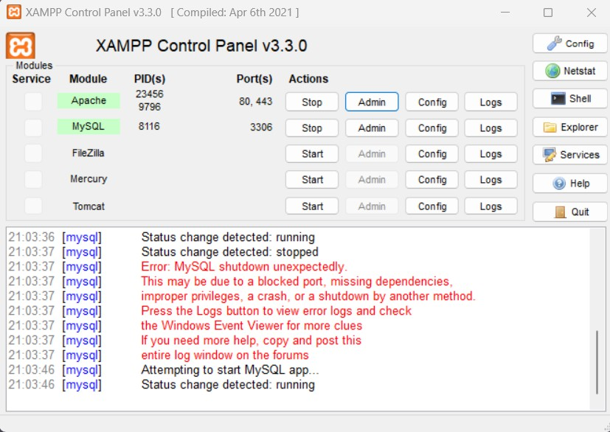
- After clicking on the “Admin” button, you will be redirected to http://localhost/phpmyadmin/.
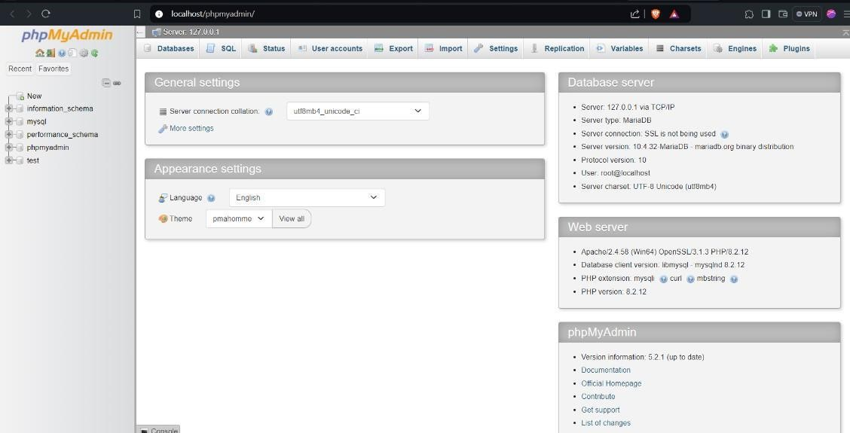

- We will now import the required databases to perform nested sub queriesin SELECT clause.
- Create a database named ‘banking’ and import the banking database into it.
- Similarly, create another database named ‘university’ and import the university database into it.
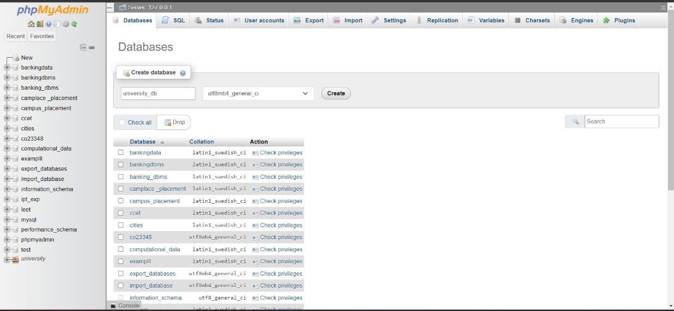
- After the tables have been imported we can view their structures and tables by clicking on the Browse button on the topmost toolbar.
- Running 5 different SQL nested sub queries in select clause on each “Banking, University and database Project assigned to each student”:

In the University database:

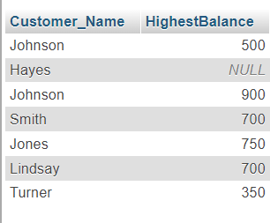
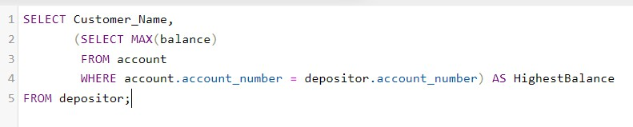
    - Retrieve customer names and their highest balance:
    - Find the total number of accounts for each customer:
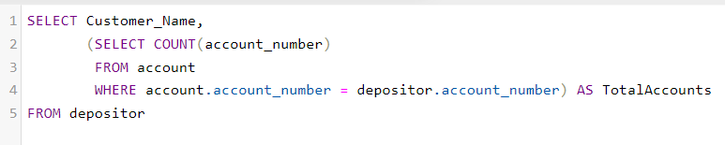
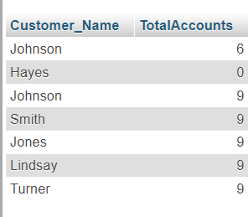

    - Fetch customer names and the average balance of their accounts:
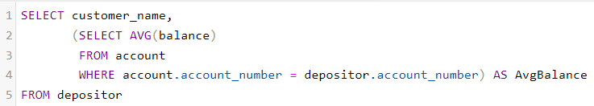
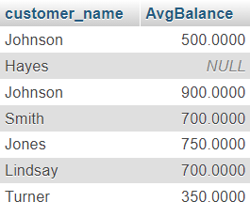

    - Display customers whose accounts have a minimum balance less than 5000:
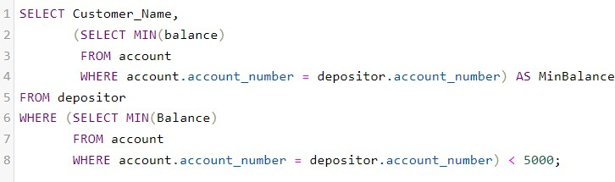
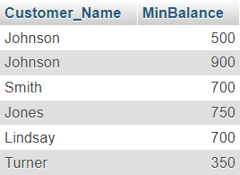

    - Show the total balance across all accounts for each customer:
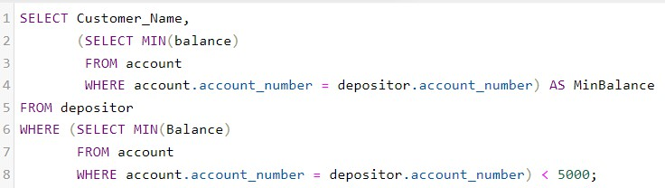
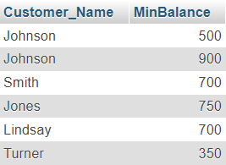

In Banking Database:

- Find the Instructor's Name Who Advises Each Student:
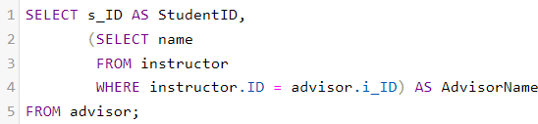
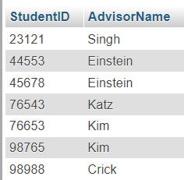
- Count the Number of Students Each Instructor Advises:
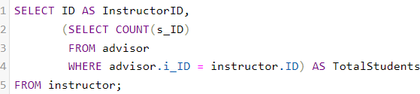
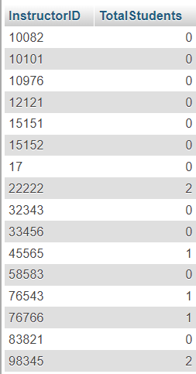
- Retrieve the Instructor ID for Each Student:
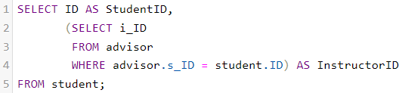
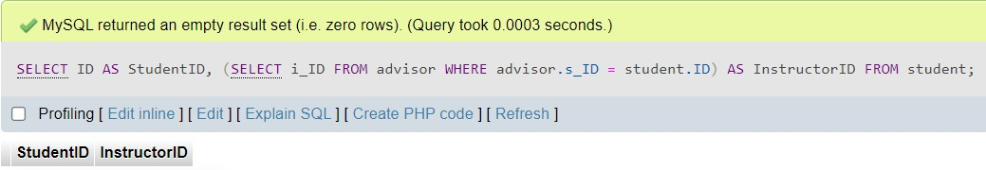

- Count the Number of Advisors for Each Student:
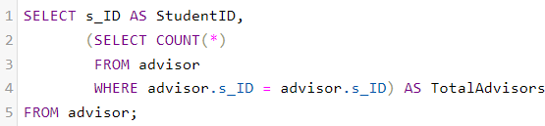
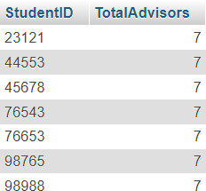
- Find the Total Number of Advisors (If Any):
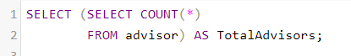
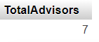

In the Database Project Assigned:
Write Off of Computational Items:

- Faculties with More Than One Printer Issue in the Same Room
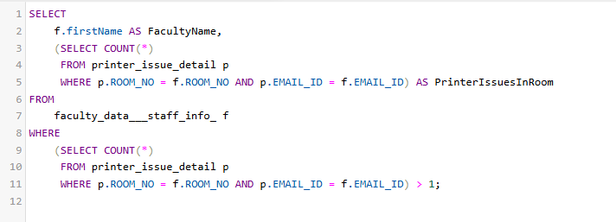

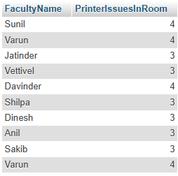

- Faculties Without Any Printer Issues
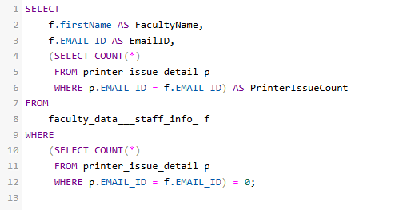

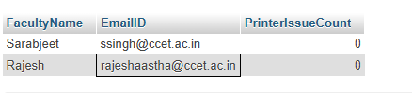

3) Find Faculty with the Most Printer Issues:

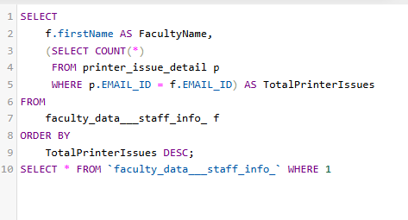
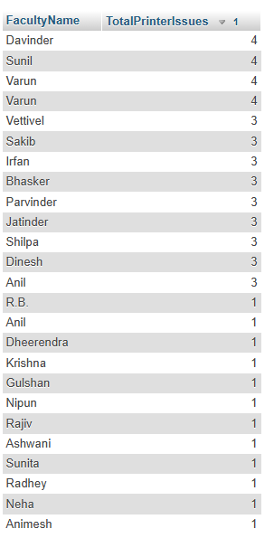s

- Identify Faculty with Priority Printer Models Based on Issue Counts
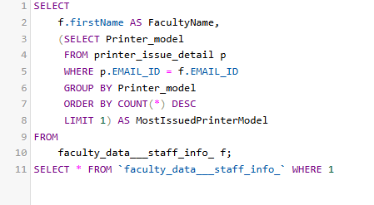
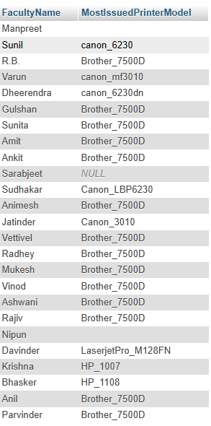

- Get the Latest Printer Refill Date for Each Faculty
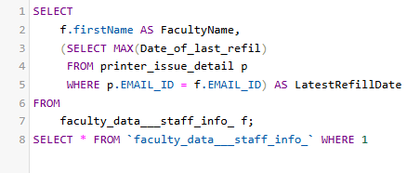
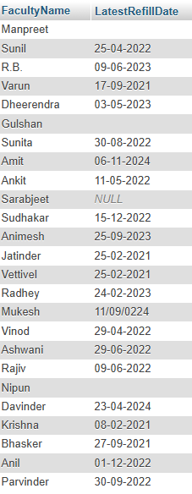

- Printer Model for a Specific Faculty
